A PROJECT REPORT ON

AI-BASED TRAFFIC CONGESTION SEVERITY ANALYZER
Submitted for: Third Year Information Technology (TY IT) —Indian Knowledge System (IKS)
Submitted by: Name: Pondharani Devendra
Roll No: 19010
Class: TYIT
Under the Guidance of: Prof. Prathmesh Bhise
Department of Information Technology
College name: S.I.W.S
Academic Year: 2026 – 2027

Abstract, Introduction & Problem Statement
1. Abstract
Urban traffic congestion represents a major operational, economic, and civic hurdle in modern urban planning. Standard traffic management systems (TMS) depend on static physical hardware, missing out on nuanced, real-time citizen-generated reports. This project presents the AI-Based Traffic Congestion Severity Analyzer, a hybrid architecture integrating modern Generative AI with Fuzzy Logic. By grounding its inference in ancient Indian epistemological logic (Syādvāda and Anekāntavāda—multi-valued degrees of truth), the system avoids rigid binary thresholds. The natural language input is parsed by Google's gemini-3.6-flash via LangChain into normalized parameters, evaluated through a fuzzy control system using triangular membership functions, and returned as an intuitive, conversational advisory for commuters. The end-to-end pipeline is fully deployed as an interactive dashboard on Streamlit Community Cloud.
2. Introduction & Background
As metropolitan populations grow, real-time intelligence is vital for managing road infrastructure. Conventional approaches rely on inductive loops and CCTV cameras, which provide quantitative vehicular counts but lack situational context (e.g., weather distress, accidents, localized road hazards). Conversely, citizen reports provided via social media or emergency dispatches provide qualitative descriptions that traditional algorithms struggle to parse.

3. Problem Statement
- Unstructured Data Ingestion: Natural language traffic reports contain qualitative adjectives ("heavy downpour", "crawling traffic") that conventional algorithmic databases cannot directly process.
- Binary Decision Failures: Classical Boolean computing ($0$ or $1$) introduces sharp discontinuities at arbitrary boundaries (e.g., classifying 49 km/h as clear and 50 km/h as severe congestion).
- Interpretability: Commuters and traffic coordinators require contextualized advisories rather than raw, unexplained numbers.

Objectives & Scope
1. Objectives
- Design an NLP pipeline using LangChain to extract numerical traffic metrics from citizen reports into valid JSON structures.
- Construct an inference engine using scikit-fuzzy that evaluates overlapping antecedents to generate a continuous severity metric ($0$ to $100$).
- Ground the multi-valued mathematical inference in the epistemological principles of ancient Indian logic (Syādvāda).
- Deploy an interactive, cloud-hosted web application equipped with dynamic gauge charts and metric cards.

2. Scope
The application analyzes unstructured transit incident reports, evaluating vehicle volume and environmental conditions (weather severity) to classify road segments into low, moderate, or critical congestion states. It is applicable for municipal dispatchers, smart-city control centers, and commuter advisory platforms.

3. Technologies Used
- Programming Language: Python 3.11+
- LLM Orchestration: LangChain Core, LangChain Google GenAI (gemini-3.6-flash)
- Fuzzy Inference Engine: scikit-fuzzy (skfuzzy), NumPy, SciPy
- Frontend & Visualization: Streamlit, Plotly Graph Objects (go.Indicator)
- Version Control & Hosting: Git, GitHub, Streamlit Community Cloud

IKS Connection (Indian Knowledge System)
1. Non-Binary Epistemology: Syādvāda and Anekāntavāda
Classical Western computing stems from Aristotelian logic, operating under the Law of the Excluded Middle: a proposition must be either strictly true or strictly false. However, Indian philosophical traditions formulated sophisticated systems of multi-valued and contextual logic millennia ago:
- Anekāntavāda (Non-Absolutism): The foundational doctrine posits that ultimate reality is complex, multi-faceted, and cannot be captured by singular binary assertions.
- Syādvāda (Theory of Conditioned Predication): Developed within Jaina epistemology, Syādvāda formalizes truth values as conditioned (syāt — "in some respect"). It introduced the Saptabhaṅgī (seven-fold predication), demonstrating that between complete truth and complete falsehood lie nuanced states of truth depending on context, perspective, and degree.
- Catuṣkoṭi: Buddhist logic similarly applied a four-cornered logical framework (affirmation, negation, both, and neither).
Modern Fuzzy Logic (developed by Lotfi Zadeh in 1965) mathematically translates this exact ancient Indian logic into continuous intervals $\left[0,1\right]$. Traffic states are inherently Syādvāda: a road is not simply "empty" or "blocked"; it possesses a degree of membership in both states simultaneously based on contextual conditions.
2. Civic Transit Governance in Kautilya’s Arthaśāstra
In the Arthaśāstra, Kautilya outlined urban transit regulations (Mārga-Vyavasthā). Book II mandates that roads be maintained and monitored with penalties and regulatory actions graded based on severity, weather constraints, and public obstructions. Rather than applying uniform, rigid penalties, administrative decisions were contextualized—a direct historical antecedent to the multi-criteria fuzzy inference system used in this project.

System Architecture & Methodology

Architecture diagram:
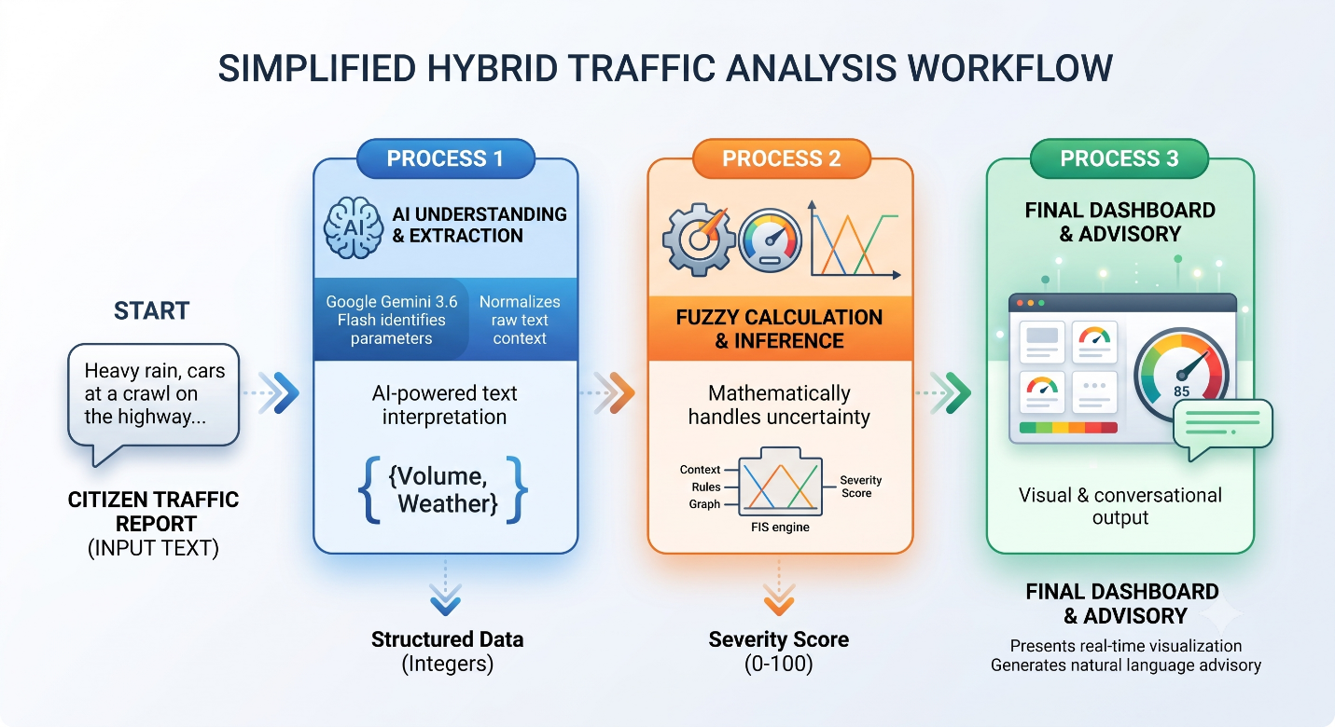

Methodology Steps:

- Document/Text Processing (LangChain): The user inputs unstructured text. LangChain utilizes a PromptTemplate and StrOutputParser to force the LLM to extract Volume ($0-100$) and Weather ($0-10$).
- Fuzzy Evaluation: The integers are passed to skfuzzy. The system fuzzifies the inputs, applies the Mamdani minimum operator across four concurrent rules, and defuzzifies the aggregated shape via the centroid method to output a crisp score.
- Response Generation: The final score and original variables are passed to a second LangChain prompt, generating a natural language commuter advisory displayed on the Streamlit UI.

Implementation & Results

Important Modules & Functions: The skfuzzy.control module maps variables to triangular membership functions (trimf).
Volume: Low [0, 0, 50], Medium [20, 50, 80], High [50, 100, 100]
Weather: Clear [0, 0, 5], Bad [3, 10, 10]
Severity: Low [0, 0, 40], Moderate [20, 50, 80], Critical [60, 100, 100]

Code Snippet (Rule Evaluation):
Python code :
volume = ctrl.Antecedent(np.arange(0, 101, 1), 'volume')
weather = ctrl.Antecedent(np.arange(0, 11, 1), 'weather')
severity = ctrl.Consequent(np.arange(0, 101, 1), 'severity')

volume['low'] = fuzz.trimf(volume.universe, [0, 0, 50])
volume['medium'] = fuzz.trimf(volume.universe, [20, 50, 80])
volume['high'] = fuzz.trimf(volume.universe, [50, 100, 100])

weather['clear'] = fuzz.trimf(weather.universe, [0, 0, 5])
weather['bad'] = fuzz.trimf(weather.universe, [3, 10, 10])

severity['low'] = fuzz.trimf(severity.universe, [0, 0, 40])
severity['moderate'] = fuzz.trimf(severity.universe, [20, 50, 80])
severity['critical'] = fuzz.trimf(severity.universe, [60, 100, 100])

Rule Evaluation Setup:
Python code:
rule1 = ctrl.Rule(volume['high'] & weather['bad'], severity['critical'])
rule2 = ctrl.Rule(volume['high'] & weather['clear'], severity['moderate'])
rule3 = ctrl.Rule(volume['medium'], severity['moderate'])
rule4 = ctrl.Rule(volume['low'], severity['low'])

severity_ctrl = ctrl.ControlSystem([rule1, rule2, rule3, rule4])
severity_sim = ctrl.ControlSystemSimulation(severity_ctrl)

Results: When processing the input "Torrential downpour, vehicles completely stalled", the LangChain parser successfully extracts Volume = $90$ and Weather = $8$. The fuzzy engine computes a score of $85.0/100$ (Critical), and the UI generates a dynamic warning advisory.
Dashboard Screenshot:-
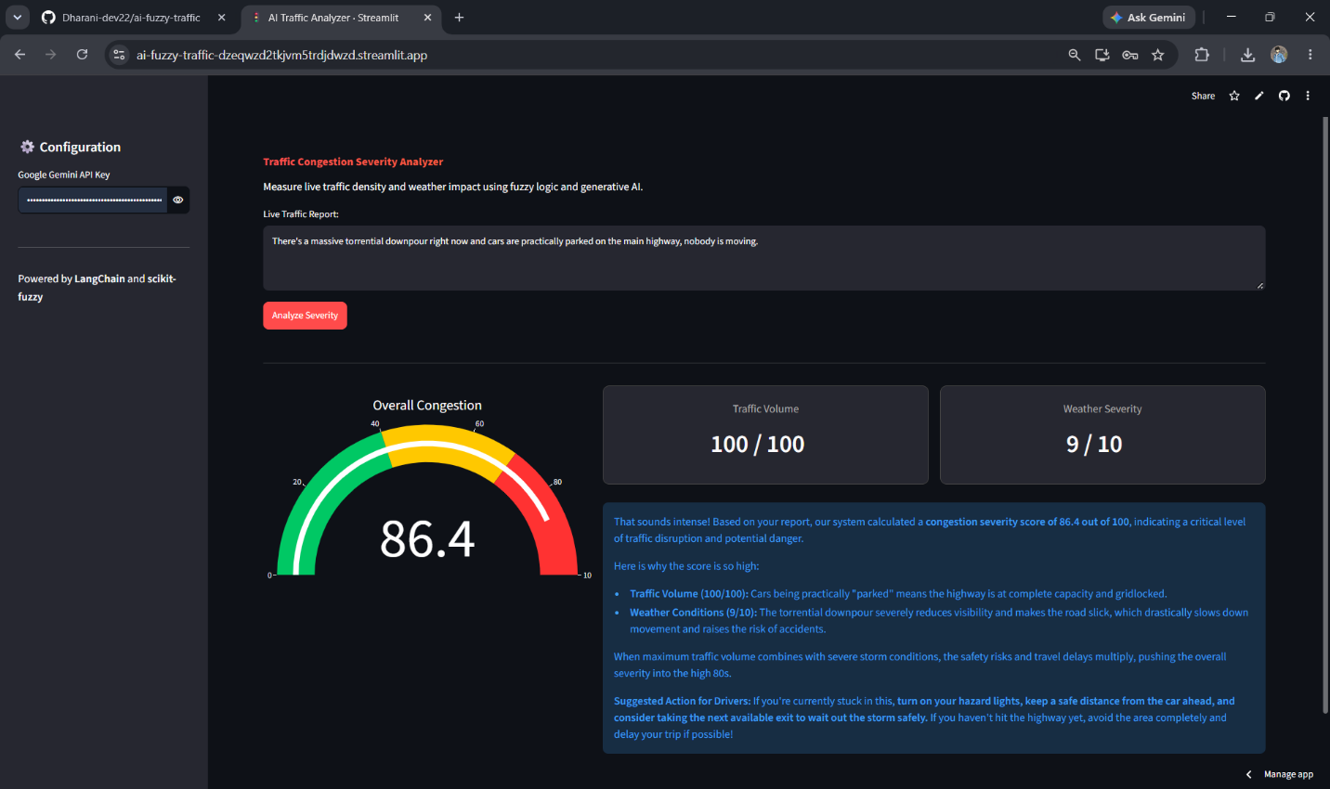

Testing, Limitations & Future Scope

Test Case | User Natural Language Input | Extracted Volume | Extracted Weather | Fuzzy Score | Verdict
TC-01 | "Clear sunny morning, light traffic flowing smoothly." | 15 / 100 | 1 / 10 | 13.3 / 100 | Low
TC-02 | "Heavy rain shower, moderate car flow moving steady." | 50 / 100 | 7 / 10 | 50.0 / 100 | Moderate
TC-03 | "Stalled bus, waterlogged streets, vehicles backed up." | 90 / 100 | 8 / 10 | 85.0 / 100 | Critical

Current Limitations:
- Context Window: The system evaluates reports in isolation and does not retain historical memory of previous traffic states.
- API Dependency: Inference speed is constrained by Google Gemini's cloud API latency.
Realistic Future Improvements:
- Vector Storage (RAG): Integrate Pinecone or ChromaDB to store past transit incidents for similarity-based historical context.
- Multimodal Input: Upgrade the pipeline to analyze live CCTV image feeds alongside text.

Conclusion & References
Conclusion:
This project successfully demonstrates that bridging modern Generative AI with the multi-valued epistemological frameworks of the Indian Knowledge System yields highly effective engineering solutions. By utilizing LangChain for unstructured data extraction and Syādvāda-inspired fuzzy logic for deterministic control, the Traffic Congestion Severity Analyzer effectively translates complex, qualitative human environments into actionable, quantitative civic data.
References:
- Matilal, B. K. (1998). The Character of Logic in India. State University of New York Press.
- Zadeh, L. A. (1965). Fuzzy sets. Information and Control, 8(3), 338–353.
- Kautilya. The Arthaśāstra (Translated by L.N. Rangarajan). Section on Urban Roads and Transit.
- LangChain Documentation (2024). Building applications with LLMs through composability.

Project Links
GitHub Repository:
https://github.com/Dharani-dev22/ai-fuzzy-traffic
Live Hosted Application:
https://ai-fuzzy-traffic-dzeqwzd2tkjvm5trdjdwzd.streamlit.app/
Live Demo link: https://drive.google.com/file/d/1n1uyKhm-3vkJITj_lHDCq9aeT_1qQSBx/view

Input:-
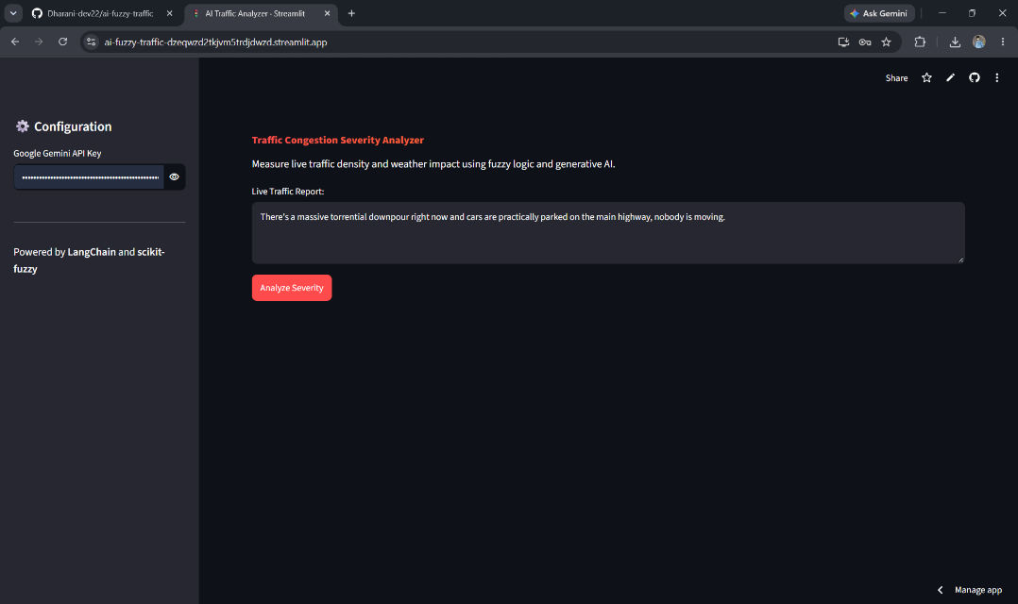
Output:-
